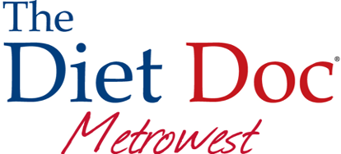
CONSENT AND LIABILITY WAIVER

I, _________________________________, hereby affirm that I am entering a course or instruction in physical fitness and/or performance training and/or nutritional consultation. By enrolling in this course I certify that I am cognizant of all of the inherent dangers of physical fitness and therapy, nutrition and diet changes, and the basic safety rules for activities connected herewith.

I understand and agree that neither The Diet Doc Metrowest, Bonnie’s Bootcamp, nor Bonnie K. Morrissey, may be held liable in any way for any occurrence in connection with my physical fitness and performance or nutrition/diet changes, which may result in injury, death, or damages to me or my family, heirs, or assignees. I further acknowledge and forever release The Diet Doc Metrowest, Bonnie K. Morrissey, or Bonnie’s Bootcamp owners, operators, agents, or instructors in connection directly or indirectly with my physical fitness training and therapy and nutrition/diet changes as a result of The Diet Doc Metrowest, Bonnie K. Morrissey, or Bonnie’s Bootcamp owners, operators, agents, or instructors’ own negligence, which may result in injury, death, or damages to me or my family, heirs, or assignees.

In consideration of being allowed to enroll in this course I hereby personally assume all risks connected with the course, and I further release the instructors, program, agents, and operators, including but not limited to the persons mentioned for any injury or damage which may be incurred by me while I am enrolled in the fitness or performance course and nutrition/diet programs, including all risks connected therewith, whether foreseen of unforeseen; and further to save and hold harmless the program and persons from any claim by me, or my family, estate, or heirs, or assignees, arising out of my enrollment and participation in this course.

I further state that I am of lawful age and legally competent to sign this aforementioned release; that I understand that the terms herein is contractual and not a mere recital; and that I have signed this document as my own free act.

I have fully informed myself of the contents of this aforementioned and release by reading it before I sign it, I have been advised to submit at my own expense and time, to a medical examination to ensure myself, and assume my own responsibility of physical fitness and capability to perform under the normal conditions of the fitness and therapy program and/or nutrition/diet program, and am physically fit as tested by medical examination. I also understand that the owner reserves the right of membership.

I agree that I am purchasing a consulting program, which requires skill and assessment of professional staff. I understand that customized programming is being created solely for me. Due to the proprietary and intellectual property involved, refunds will not be issued.

Client Signature:_______________________________Date:_________________________

